**SRS (Software Requirement Specification)**

**Functional Requirements:**

1. The robot should be able to recognize different voice commands from the user.
2. The robot should respond to the recognized commands by performing the appropriate actions.
3. The robot should have a default mode where it waits for the user's voice commands.
4. The robot should be able to recognize the user's voice and respond with personalized messages or actions.
5. The robot should be able to move in different directions and turn around based on voice commands.
6. The robot should be able to manipulate objects based on voice commands, such as picking up or dropping items.
7. The robot should be able to perform predefined tasks, such as cleaning a room, when given the appropriate voice command.

**Non-Functional Requirements:**

1. The system should have high accuracy in recognizing voice commands.
2. The system should be able to handle noisy environments and still recognize voice commands.
3. The system should have low latency between voice recognition and response.
4. The system should have a natural and human-like response to voice commands.
5. The system should have a user-friendly interface for controlling and customizing voice commands.
6. The system should have a secure and reliable connection between the robot and the user's voice input device.
7. The system should have a backup power supply in case of power failure to ensure continuous operation.

**DFD of Voice Controlled Robot**

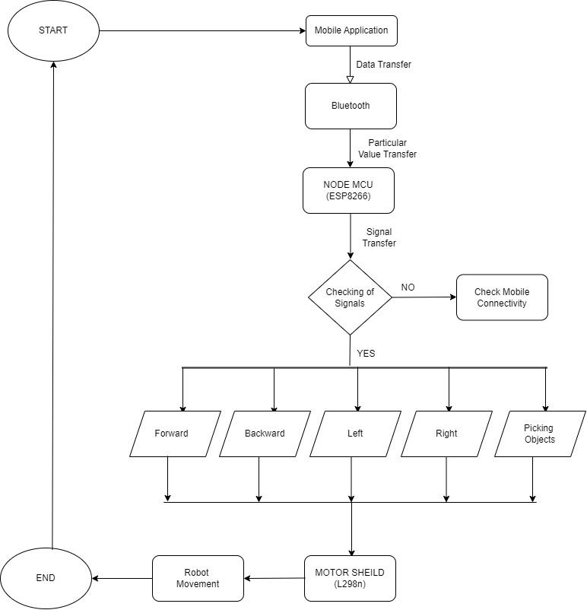

**ERD of Voice Controlled Robot**

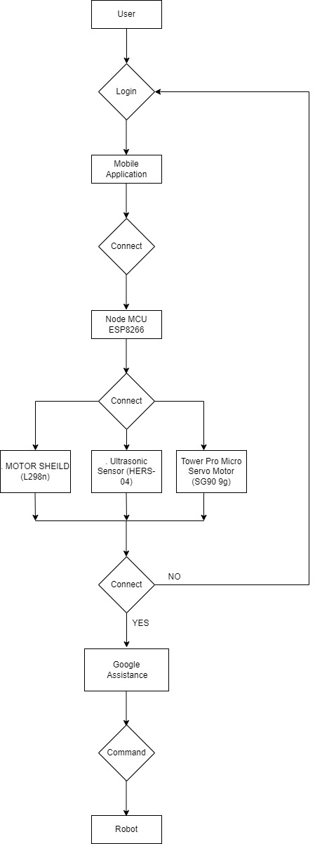

**UML of Voice Controlled Robot**

**Use Case Diagram:**

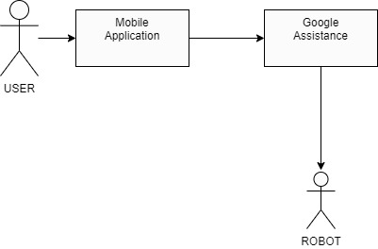

**Class Diagram:**

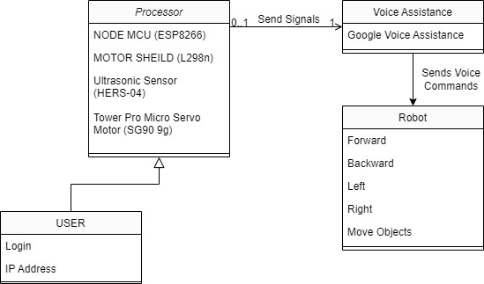

**Activity Diagram:**

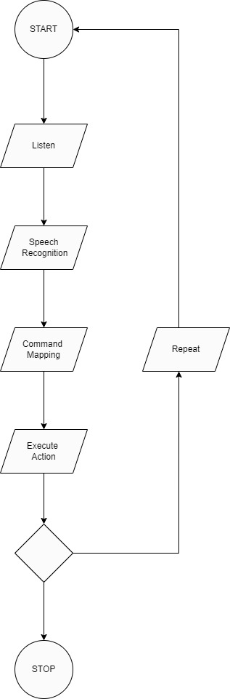

**Sequence Diagram:**

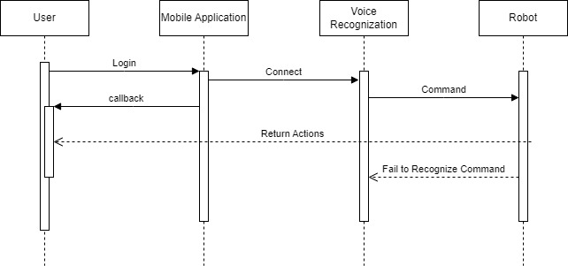

**Data Structure of Voice Controlled Robot:**

The data structure of a voice-controlled robot depends on the specific implementation and the complexity of the system. However, here are some common data structures that are typically used in voice-controlled robots:

1. Command List: This data structure stores a list of recognized voice commands along with the corresponding actions that the robot should take when the command is recognized. Each command is typically represented as a string, and the corresponding action can be represented as a function or a sequence of instructions.
2. Voice Signal Buffer: This data structure is used to temporarily store the voice signal received from the microphone before it is processed by the speech recognition algorithm. The buffer can be implemented as a circular buffer or a queue, depending on the requirements of the system.
3. Speech Recognition Model: This data structure represents the machine learning model used for speech recognition. The model is typically trained on a large dataset of voice samples to learn the patterns and characteristics of different words and phrases. The model can be represented as a neural network, a decision tree, or a Hidden Markov Model (HMM).
4. User Profile: This data structure is used to store information about the user, such as their name, preferences, and history of voice commands. The user profile can be used to provide personalized responses or to adapt the system's behaviour to the user's preferences.
5. Motor Control Commands: This data structure is used to send commands to the motors and other actuators that control the robot's movement. The commands can include instructions to move forward, backward, turn left, turn right, or stop.
6. Sensor Readings: This data structure is used to store the readings from the robot's sensors, such as proximity sensors, ultrasonic sensors, or temperature sensors. The sensor readings can be used to adjust the robot's behaviour based on the environment or to provide feedback to the user.

Overall, the data structure of a voice-controlled robot is a crucial component of the system's design. It determines how the system stores and processes information, and how it interacts with the user and the environment. A well-designed data structure can make the system more efficient, reliable, and user-friendly.